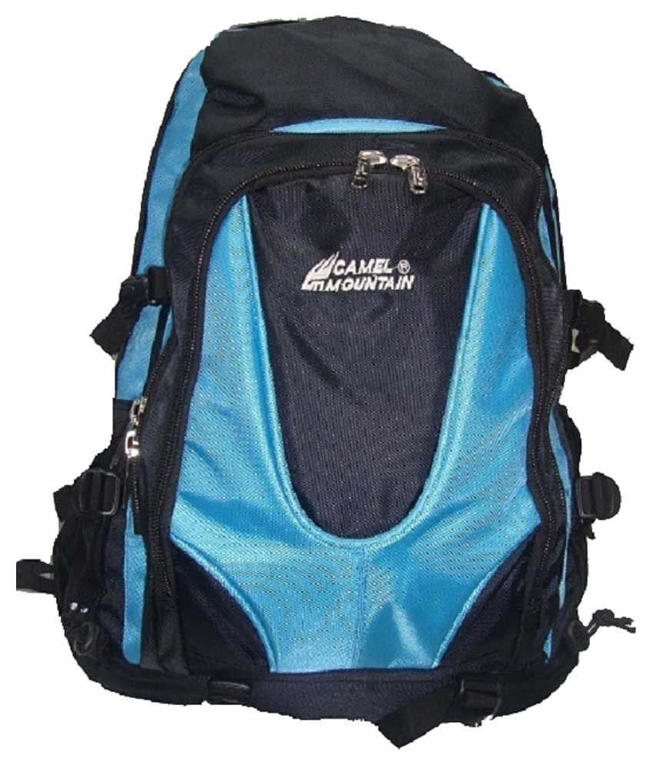

# CAMEL MOUNTAIN BLUE& BLACK -009

|  |  |
| --- | --- |
| BRAND | CAMEL MOUNTAIN |
| ITEM DIMENSION | 2 x 4 x 12.13inches |
| MODEL NAME | 009 |
| COLOR | BLUE & BLACK |
| PRICE | **RS 1800** |